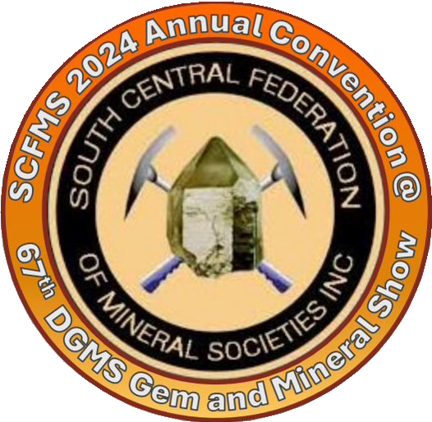
South Central Federation of Mineral Societies Arkansas • Louisiana • Texas

2026 Convention Registration Form

The South Central Federation of Mineral Societies Inc.’s
2026 Annual Meeting will be held in conjunction with:

Houston Gem and Mineral Society’s 73rd Annual Show
November 14 (9-6), 15 (9-6) and16 (10-5), 2026
Humble Civic Center
8233 Will Clayton Pkwy, Humble Texas 77338

Please complete a form for each person attending.

Name: Phone Number:
Email Address: Society Name: Representative:

Event | Cost | # Attending | Total Cost
Editors/Webmasters Breakfast | $25
Awards Dinner Buffet | $35
Show Ticket | $10
Total


Please email completed form to Editor@hgms.org Forms must be received by Tuesday, October 15, 2026
Payment can be made via QR Code at right or Check
Checks should be made out to:
Houston Gem and Mineral Society
Include “2026 SFMS” in memo field and mail to:

Houston Gem and Mineral Society
10805 Brooklet Dr, Houston, TX 77099
Payment must be received by Friday November 1, 2026
Preferred Lodging: Staybridge Suites, 7195 Will Clayton Pkwy, Humble TX 77338

Reservations will be closed October 15th.
Reservations Booking Link

Activities:
All activities for the SCFMS Annual Convention will take place on Saturday November 15th at the Humble Civic Center in Humble, Texas, in the Hospitality area of the set-up for the HGMS Annual Show.
- Editors/Webmasters Contest will be held from 8:00am to 10:00am.
- SCFMS Annual Convention will be held from 2:00pm to 4:00pm
- The Award Dinner will take place at 7:00pm.
Rollin Rock Club will as usual be at 9:00am on Sunday morning, before the Show opens.
If anyone is interested in visiting the HGMS clubhouse, that will have to take place on Monday, as club members will be busy with Show activities.
Why Staybridge Suites? It is on of the closest hotels to the Humble Civic Center, it has good ratings and they can provide a a gathering place and a shuttle. We thought that might reassure people who are uncertain about navigating Houston traffic.

There are of course other hotels:
• Regency Inn & Suites
• WoodSpring Suites Houston IAH Airport
• Ramada by Wyndham Houston Intercontinental Airport
• East La Quinta Inn & Suites by Wyndham
• Holiday Inn Houston NE
• Palace Inn IAH Houston
• TownePlace Suites by Marriot
• Comfort Suites Humble Houston IAH

Houston Area Attractions:
• Houston Museum of Natural Science
• Katy Rock Shop
• The Focal Crystal Downtown Acquarium
• Houston Botanic Gardens
• Mercer Gardens
• Space Center Houston
• The Museum of Fine Arts, Houston
• Bayou Bend Collection

